Smart and Secure Saline, Heartbeat, Temperature Monitoring System

Kalaivani K
Electronics and Instrumentation Engineering
Easwari Engineering College
Chennai, India
kalaivani.k@eec.srmrmp.edu.in
Dhanush S
Electronics and Instrumentation Engineering
Easwari Engineering College
Chennai, India
srmeeceie.dhanush@gmail.com
Thirumal P
Electronics and Instrumentation Engineering
Easwari Engineering College
Chennai, India
thirumalperumal2003@gmail.com
Aravindan P
Electronics and Instrumentation Engineering
Easwari Engineering College
Chennai, India
srmeeceie.aravindan@gmail.com

Abstract— Saline is one of the most commonly used intravenous therapies for managing critically ill patients. However, accidents can occur due to the ignorance of caretakers, and remote monitoring is necessary for providing effective telehealth services. To address these issues and provide cost-effective remote surveillance, a smart monitoring device is proposed. This device incorporates sensors and IoT technologies to monitor saline levels, heartbeat, and temperature. The monitoring system is designed to improve patient safety and enhance telehealth services.

Keywords— Saline, Remote monitoring, Heartbeat, Temperature

Introduction
Adequate hydration through a saline drip is critical during surgery, and recent research shows that maintaining the right balance of salt and water can have a significant impact on patient recovery. Researchers at Thomas Jefferson University found that using a slightly saltier intravenous drip (hypertonic saline) and lower total volume of fluid reduced the overall rate of complications by 25 percent after the complex Whipple surgery for pancreatic cancer.

However, as the saline bottle goes below a certain level, it is necessary to replace it. To address this issue, an IoT-based saline level monitoring system has been developed, which aims to provide an authentic, accessible, easy, and cost-effective system for saline level monitoring.

The system includes IR sensors that are used to determine the status of the liquid in the bottle, whether it is normal or warning status. When the saline level goes below a certain threshold, an alarm will sound, and a notification will be sent to the nurse's mobile phone. This system enables nurses to monitor the amount of saline even from the control room, reducing the need for frequent checks at the patient's bedside.

The system also includes level sensors to detect the drop rate of saline accurately. The output obtained from the sensors is processed to check whether the saline bottle is empty. The system can wirelessly send data to nurses or doctors' computers and display the results in the form of saline droplet rate, number of droplets coming from the saline bottle, saline solution given to the patient in ml, and the remaining time to empty the saline bottle with the help of serial port test software.

The main advantage of this system is that it reduces human interference, which can be especially useful in rural or low-resource settings. Additionally, this system is low-cost, easy to use, and provides an efficient solution to the problem of monitoring saline levels during patient care.

In summary, an IoT-based saline level monitoring system has been developed to ensure adequate hydration during surgery and patient care. This system is a significant advancement in healthcare technology and has the potential to improve patient outcomes by ensuring that patients receive the appropriate amount of saline and reducing the risk of complications.

Literature survey

1) “Design and Development of Saline Infusion Administration System Using IoT”

• According to the current deficiency of medical personnel due to many COVID-19 patients today, the workload of nurses and caregivers increases.
• The Arduino UNO R3 and Node MCU ESP8266 microcontroller board are used as a processor to receive the saline weight input from the load cell and control the saline flow rate by the servo motor arm.
• The developed system can also be remotely monitored and controlled online via Wi-Fi, Internet, and cloud computing with mobile and web applications developed by Flutter.
• From the results of trying that determine the saline flow rate with different periods, it was found that the system was able to control the flow rate for the specified time with a total meantime accuracy of 88.47%.

2) “Smart Saline Bottle for Remote Patient Monitoring using Iot”.

• The significant and principal prerequisite of the hospitalized patients is that each persistent ought to be given a superior treatment and perception and be provided the right measure of essential nutrition at the right time.
• The Healthcare area with imaginative strategies has gotten effortless everyday life. Computerization of the saline system is the need of emergency clinics.
• Saline is something fundamental utilized in each emergency clinic to convey drugs to the patient to fix them. At whatever point saline is taken care of to the patient, medical attendants and overseers have to screen it because of

• distractedness of attendants towards saline or absence of patient to nurture proportion in the medical clinic causing aeroembolism, which may lead to heart attack, respiratory failure

3) “Patient Health and Saline Level Monitoring System using IoT”

• In this paper, a sensor is attached to the patient's body to collect all signals from the wireless sensors and sends them to the base station.
• The system allows the anesthesiologist to simultaneously monitor and share the Android app through a cloud-based solution. More than one patient can be monitored at a time. The main advantage of this system compared to previous systems, is that it reduces energy consumption and safety.
• The Android app can connect multiple patients at once, so the anesthesiologist can easily follow different surgeries in parallel.
• In addition, automatic monitoring of the proposed saline level consists of level sensors that are used to determine the status of the liquid in the bottle, either normal or alert. The detection of saline drop rate is quite reliable.

4) “IoT Based Smart Saline Level Monitoring System “

• saline bottle level is very important because when the bottle is emptied and the needle is not removed from the vein then the blood flows outward into the bottle. In hospitals, the nurses or caretakers are responsible for monitoring the saline bottle level.
• Mostly, due to negligence and any unusual condition, the exact timing of removing the needle from the patient’s vein is ignored which causes a serious casualty and may lead to death as well. Furthermore, remote monitoring is a need to provide telehealth services.
• To prevent the accident due to the ignorance of caretakers and to provide remote surveillance in telehealth services, we have proposed the cost-effective smart

saline level monitoring device which includes the combination of sensor and Internet of Things (IoT) technologies.
• We have built this system by using load sensor and ultra-low power low cost ESP32 WiFi System on Chip (SoC) microcontroller. The load sensor converts the weight of the bottle to a specific voltage.
• The ESP32 microcontroller generates and publishes a specific message based on the voltage received from the sensor.
• This proposed monitoring system fulfills the reliable delivery of messages to the subscribers which is very important for healthcare.

5) “NRF Transceiver based Saline Level, Health Monitoring & Control System”
• The patient demands from nurse that to continuously monitor the saline level, but at times due to remissness and heedlessness towards saline completion, their extravagant workload, a larger number of patients are being harmed in the hospitals.
• Hence to prevent the patient from getting harmed, this system has been developed which monitor the saline level continuously which is fed to the patient in addition to measure the health parameters of patients i.e. body temperature of patient, heart rate of patient and SPO2 level.
• When saline level will at critical stage & if any variations will occur in body parameters, doctors will be notified via LEDs, buzzer. Also, message will be display on LCD and SMS will send on mobile through GSM.
• This system can be utilized successfully in any hospital and it is necessary. The main purpose of this developed system is to provide reliable, convenient and automated saline and health monitoring system which can be easily implemented & easy for doctors as well as nurses to monitor from a distance. The accuracy of achieved system is 95%

6) “Fully Automated Single Window Saline Fluid Flow Control and Automatic Container Changing System”

• Due to the technology evolution many advanced techniques has been evolved for assuring quick recovery of the patients in hospitals.
• Intravenous therapy is treatment that infuses intravenous solutions, medicine, blood, blood products directly into a vein.
• In general the flow measurement of intravenous fluids or saline fluids needs to be measured and controlled.
• This existing paper a fully automated android and IoT based continuous monitoring, fluid flow control and automatic saline container changing using single window system is proposed.

7) “Intravenous Drip Monitoring System For Smart Hospital using Iot

• The Bluetooth Module equipped with Arduino has the ability to conjoin with the smartphone application.
• The sensors collect data from the patient body and IV bag and send the information The Bluetooth Module equipped with Arduino has the ability to conjoin with the smartphone application.
• The sensors collect data from the patient body and IV bag and send the information For this, we will steadily monitor the heart rate, BP, temperature of the patient, and fluid level on the IV bottle while injecting.
• If abrupt changes are coming, it will alert the medical personnel. For alerting, we use buzzer technique and messaging facility.

8) “IoT Based Medical Assistant for Efficient Monitoring of Patients in Response to COVID-19”

• Bio-medical sensors interfaced with microcontroller are used to collect the data of heart beat rate, body temperature and body movement to get an overview of the present health condition of the patient.

• The recorded data are stored in an excel file and updated automatically to the internet via OneDrive in every 30 seconds.
• In case of any large deviation from the normal condition, an automated alarm system will notify the assigned doctor about the condition of the patient.

9) “Connecting Intelligent Things in Smart Hospitals using B-IoT”

• They have implemented use of Internet of Things (IoT), especially smart wearables, will play an important role in improving the quality of medical care, bringing convenience for patients and improving the management level of hospitals.
• However, due to the limitation of communication protocols, there exists non unified architecture that can connect all intelligent things in smart hospitals, which is made possible by the emergence of the Narrowband IoT (NB-IoT).
• In light of this, we propose architecture to connect intelligent things in smart hospitals based on NB-IoT, and introduce edge computing to deal with the requirement of latency in medical process.
• As a case study, we develop an infusion monitoring system to monitor the real time drop rate and the volume of remaining drug during the intravenous infusion.
• Finally, we discuss the challenges and future directions for building a smart hospital by connecting intelligent things.

Existing System
• This existing paper described the design of an automated device to detect air bubbles during a neuroangiography, a medical procedure that takes images of the blood vessels in the brain. In the neuroangiography procedure, a saline solution is injected into the patient through a catheter without the presence of any air bubbles.
• If an air bubble enters the bloodstream of the patient it may cause an air embolism, therefore, it is crucial that all air bubbles are detected and removed during the surgery. The current process relies on a nurse to constantly monitor the intravenous(IV) line for bubbles and pinch the line manually if a bubble is detected.
• They must also ensure that the pressure of the saline bag is maintained within a certain range and the saline bag does not become empty.
• The device discussed in this paper was designed to implement these tasks automatically so the nurse’s work level stress would decrease, and their focus and energy could be directed to the patient’s well-being.

Proposed System

• This study aims to develop an automatic system of tools infusion that can monitor the condition of the infusion volume and monitor the condition of droplets performed remotely using IoT technology.
• This paper relates with the saline level of a patient through remote technology in health care centers to monitor patient’s data constantly. The design has been made simple with two main functions are remote monitoring for the

condition of the contents/detection volume of infusion fluids and drips or absence of intravenous fluids.
• The status intravenous fluid volume used by patients divided into three categories namely: Safe: intravenous fluid condition > 10%; Standby: the condition of the infusion liquid 5%-10% and Empty: 0% condition intravenous fluids If the patient is sick firstly we should give a saline to patient.
• This paper relates with the saline level of a patient through remote technology in health care centers to monitor patient’s data constantly. If the patient is sick firstly we should give a saline to patient. When the bottle is placed to patient we should check frequently the level of bottle. It is difficult to check all the time, so we transmit data through cayenne cloud platform to nurse cabin.

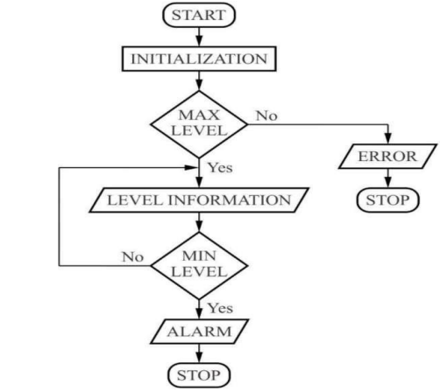

Flow Chart

• All most in all hospital, and nurse is responsible for monitoring the electrolyte’s bottle level. But unfortunately most of the time, the observer may forget to change the bottle at correct time due to their busy schedule.
• To overcome this critical situation, a IoT based automatic alerting and indicating device is proposed where sensor is used as a weight sensor. It is based on the principle that the sensor output changes when fluid weight is below certain limit. When Fluid weight is low, will alerts the observer through the display/buzzer or/and mobile phone at the control room
• Our system consists of Auto/Manual Mode. In both the mode of operation, saline level will be updated to cayenne app using IOT (ESP 8266-12E NODE MCU) module through cayenne server.
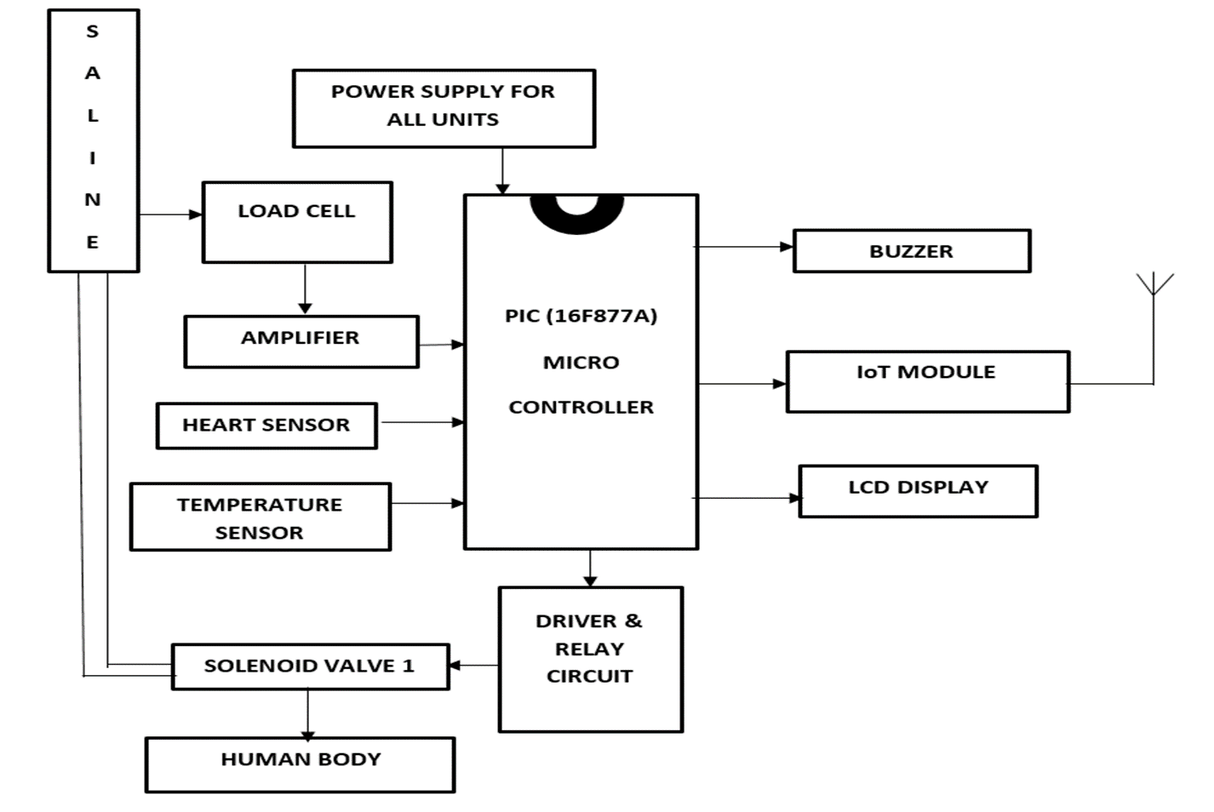

Block diagram

WORKING OF BLOCK DIAGRAM

• The whole work module is based on the saline bottle.
• The work of load cell is the calculated the weightage of saline bottle, the role of load cell is resume when the weight of the saline bottle reaches the particular rate.
• The 230V AC is converted into 5V DC voltage in the block of power supply, it supplies the power to the whole prototype work model.
• Amplifier is used to increase the amplitude of electrical signal which are received from load cell.
• The the two sensor which are heart and temperature used to calculate the heart beat and temperature level of patients.
• The buzzer started buzzering when the saline level decreases (or) the level of heartbeat and temperature increases.

• The level of saline, heartbeat and temperature are uploaded in numbers and units are written as codes in IOT board and the another use of IOT module is to transfer the signal using wifi.

• The LCD display is used to screen the values of saline level , temperature and heart beats.
• The solenoid valve can’t switch directly from the saline bottle so, the relay and driver circuit is used to make solenoid valve switch on and off.

• The whole block parts are connected to the microcontroller which is considers as heart of the work module, which consists of 40 pin.

• Which control the inputs and outputs of the whole prototype hardware module.

Experimental results

Modes Of Saline Level

1. Auto Mode

2. Manual Mode

Auto Mode

• There are two beneficial modes in our project. The first effective mode is auto mode
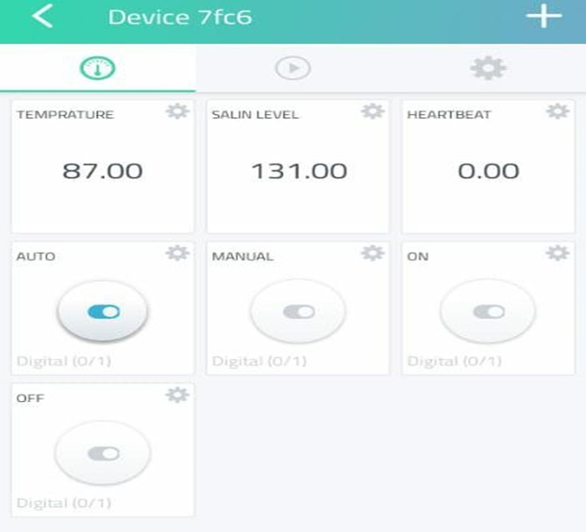

• In auto mode, we have to on auto mode toggle button in our app.
• The first two values in first row which represents temperature level and the single value in second row represents heart beat level.
• As we describe, when the saline reaches the level of below 100, this mode will automatically close the solenoid valve.

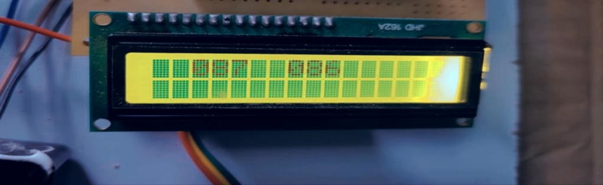 Normal Condition

• The diagram represents that saline level decreasing below 100mg when the condition is normal.
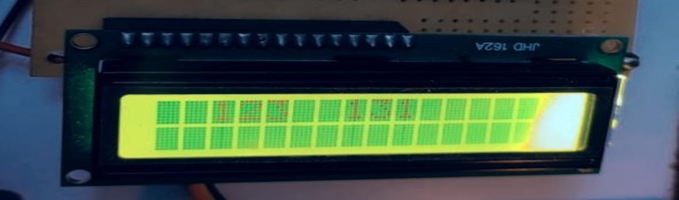
Abnormal Condition

• The Fig 6.6.2 diagram represents the saline level increasing above 100mg when the condition is abnormal (or) critical.

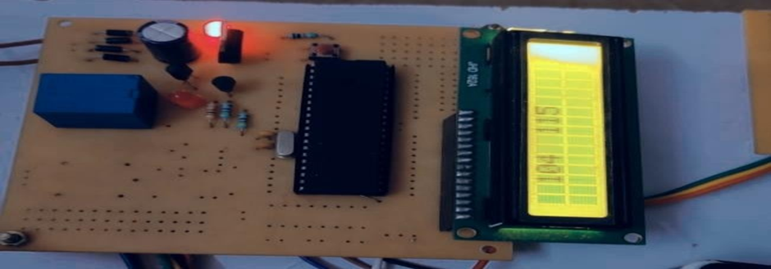
Solenoid valve OFF Condition

• As we shown in fig 6.6.1 when the heart beat and temperature level of patients exceed the auto mode will close the solenoid valve. Which we can know that the second red light will off as the indication.
6.6.4 Manual Mode

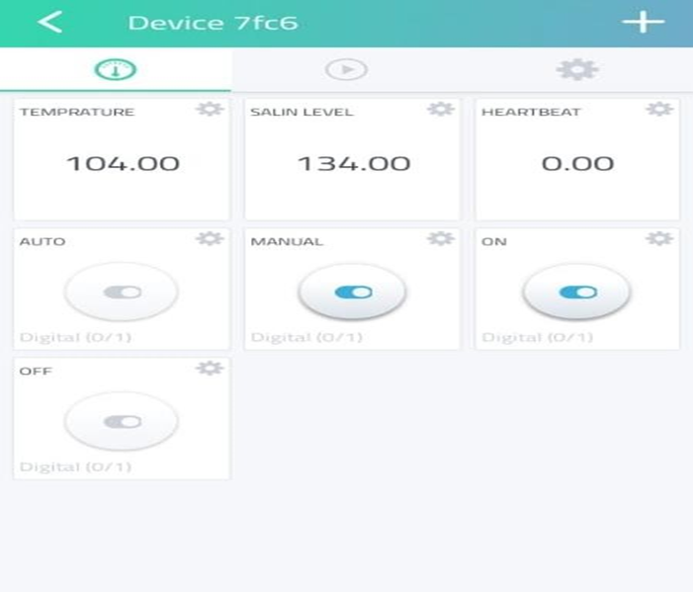
Manual Mode

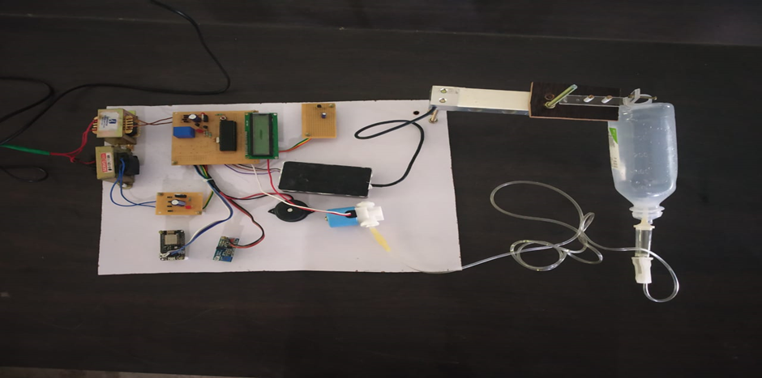
Hardware Setup

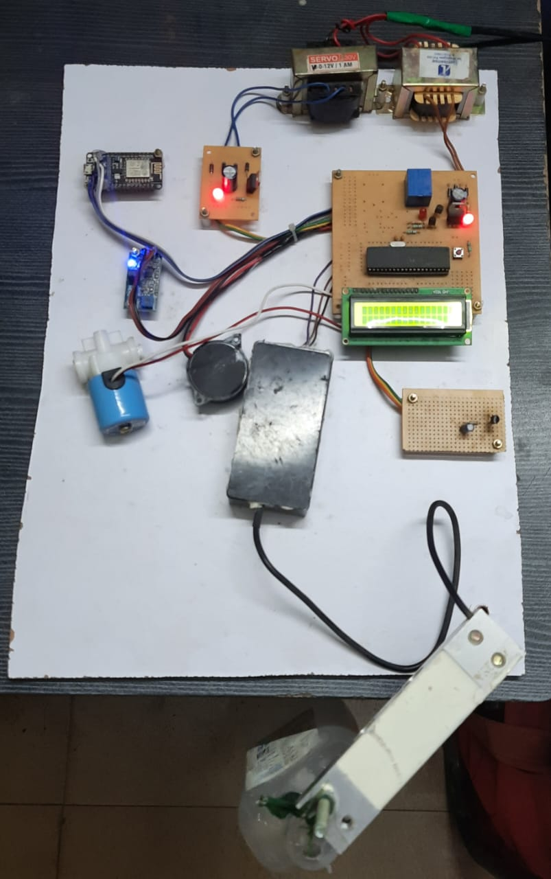
Hardware Setup ON State

• The another mode we derived here is manual mode. The only difference apart from the auto mode is to on the solenoid valve manually, as we shown in the fig 6.6.4 the caretaker should activate both manual toggle and solenoid valve toggle button to use this manual mode.

RESULTS

The result of both modes are same where the solenoid valve get close and the second red light near relay gets off.

• This project mainly assures the safety of the patient by the correct manipulation of the valves through which the saline fluid is infused to the body.
• The correct and accurate automation of the saline infusion provides the patient and the medical staff the easiness of the medication.
• This project is the doorway to many future medical enhancement in saline drip infusion management of the admitted patient will be much easier by using this technique and will avoid the risks of reverse blood flow and over dosage caused due to negligence of the staff.

Conclusion
The aim of this project is to design, develop, and experiment with a monitoring and control system for saline level solution. The system is designed to reduce the workload of nurses or caregivers by providing web and mobile apps that allow for remote monitoring and control. Additionally, the system can automatically adjust the amount of saline solution administered to patients. The equipment used in the system includes load cells, solenoid valves, and microcontroller boards, which are generally less expensive than commercially available devices.

The system is also equipped with IoT capabilities that enable it to be monitored and controlled remotely, surpassing any commercially available device on the market today. However, there is a need to improve the system's working algorithm to increase accuracy and optimize the saline solution to be more consistent, reducing errors that may arise during operation. These improvements will lead to a more reliable and efficient system that can better serve patients and healthcare providers.

References

- [1] Chuang, Cheng-Hsin, Chuang, C. H., Du, Y. C., Wu, T. F., Chen, C. H., Lee, D. H., Chen, S. M., ... & Shaikh, M. O. “Immunosensor for the ultrasensitive and quantitative detection of bladder cancer in point of care testing.”, Biosensors and Bioelectronics, vol. 84, pp. 126-132, October 2016.
- [2] Du, Y. C., Lim B. Y., Ciou W. S., Wu M. J. “Novel Wearable Device for Blood Leakage Detection during Hemodialysis Using an Array Sensing Patch.”, Sensors, vol. 16(6), pp. 849, June 2016.
- [3] Demirci, H., Satman, I., Bilgel, N., & ÇÕnar, Y. “Essentials of Diabetes Care in Family Practice.”, INTECH Open Access Publisher. 2013.
- [4] Liu, G., Liu, G., Ho, C., Slappey, N., Zhou, Z., Snelgrove, S. E., Brown, M., ... & Edwards, J. “A wearable conductivity sensor for wireless real-time sweat monitoring.”, Sensors and Actuators B: Chemical, vol. 227, pp. 35-45, May 2016.
- [5] M. Holmer, F. Sandberg, K. Solem, E. Grigonyte, B. Olde, and L. Sornmo,“Extracting cardiac signal from the extracorporeal pressure sensors ofa hemodialysis machine,”IEEE Trans. Biomed. Eng., vol. 62, no. 5,pp. 1305–1315, May 2015.
- [6] C.-H. Lin, W.-L. Chen, C.-D. Kan, M.-J. Wu, and Y.-C. Mai, “Detectionof venous needle dislodgement during hemodialysis using fractional or-der shape index ratio and fuzzy color relation analysis,”IET HealthcareTechnol. Lett, vol. 2, no. 6, pp. 149– 155, Dec. 2015.
- [7] S. Yanget al., “Cut-and-paste manufacture of multiparametric epidermalsensor systems,”Adv. Mater., vol. 27, pp. 6423–6430, 2015.
- [8] H.-C. Chuang, C.-Y. Shih, C.-H. Chou, J.-T. Huang, and C.-J. Wu, “Thedevelopment of a blood leakage monitoring system for the applicationsin hemodialysis therapy,”IEEE Sensors J., vol. 15, no. 3, pp. 1515–1522,Mar. 2015.
- [9]S. Fraser and T. Blakeman, “Chronic kidney disease: identification and management in primary care,” Pragmatic Obs. Res., vol. 7, pp. 21–32 , Aug. 2016.
- [10]A. Levinet al. “ Kidney disease: Improving global outcomes (KDIGO) CKD work group. KDIGO 2012 clinical practice guideline for the evaluation and management of chronic kidney disease,” Kidney Int. Suppl., vol. 3, no.1, pp. 1–150, Jan. 2013.
- [11]National Kidney Foundation, “K/DOQI clinical practice guidelines for chronic kidney disease: evaluation, classification, and stratification,”Am. J. Kidney Dis., vol. 39, suppl. 1, pp. S1–S26 6, 2002.
- [12]A.S. Levey and J. Coresh, “Chronic kidney disease,” Lancet, vol. 379, no. 9811, pp. 165–180, Jan. 2012.
- [13]A.C. Webster, E.V. Nagler, R.L. Morton and P. Masson, “Chronic Kidney Disease,”Lancet, vol. 389, no. 10075, pp. 1238–1252, Mar. 2017.[6]K.T. Mills et al.
- [14]J.T. Daugirdas et al. “KDOQI Clinical Practice Guideline for Hemodialysis Adequacy: 2015 Update,” Am. J. Kidney Dis., vol. 66, no. 5, pp. 884–930, Nov. 2015.[8]T.W. Meyer, T.L. Sirich and T.H. Hostetter, “ Dialysis Cannot be Dosed,” Semin. Dial., vol. 24, no. 5, pp. 471–479, Sep.-Oct. 2011.\
- [15]C. Donadio, D. Calia, S. Ghimenti, M. Onor, E. Colombini, R. Fuoco andF. Di Francesco, “Uric acid is the major determinant of absorbance in spent dialysate allowing spectrophotometric evaluation of dialysis dose,”J. Nephrol., vol. 27, no. 3, pp. 331–337, Jun.2014.

